To get custom user access on s3 bucket

<https://docs.aws.amazon.com/AmazonS3/latest/dev/example-walkthroughs-managing-access-example1.html>

1.Create bucket

2.step bucket policy

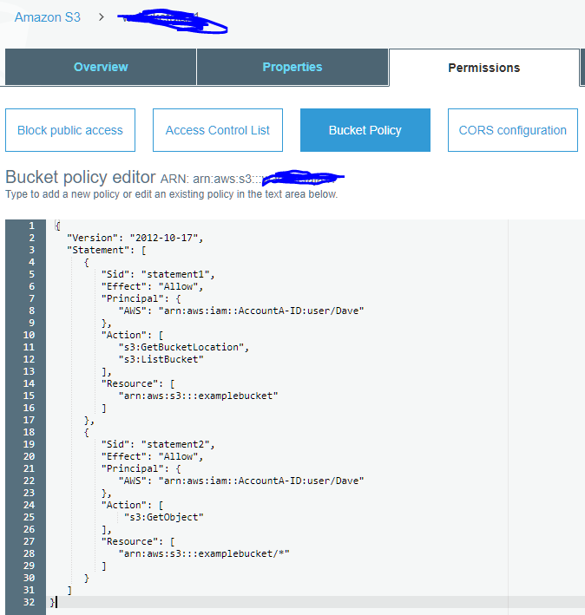

3.step create custom user policy and add it to the user

